**LINK FILE JAWABAN UAS:**

<https://drive.google.com/drive/folders/1dQqbFG1_m7KzvoRqJMg9BIY3zx_WzTZq?usp=sharing>

1. **Halaman Home Page (Guest)**

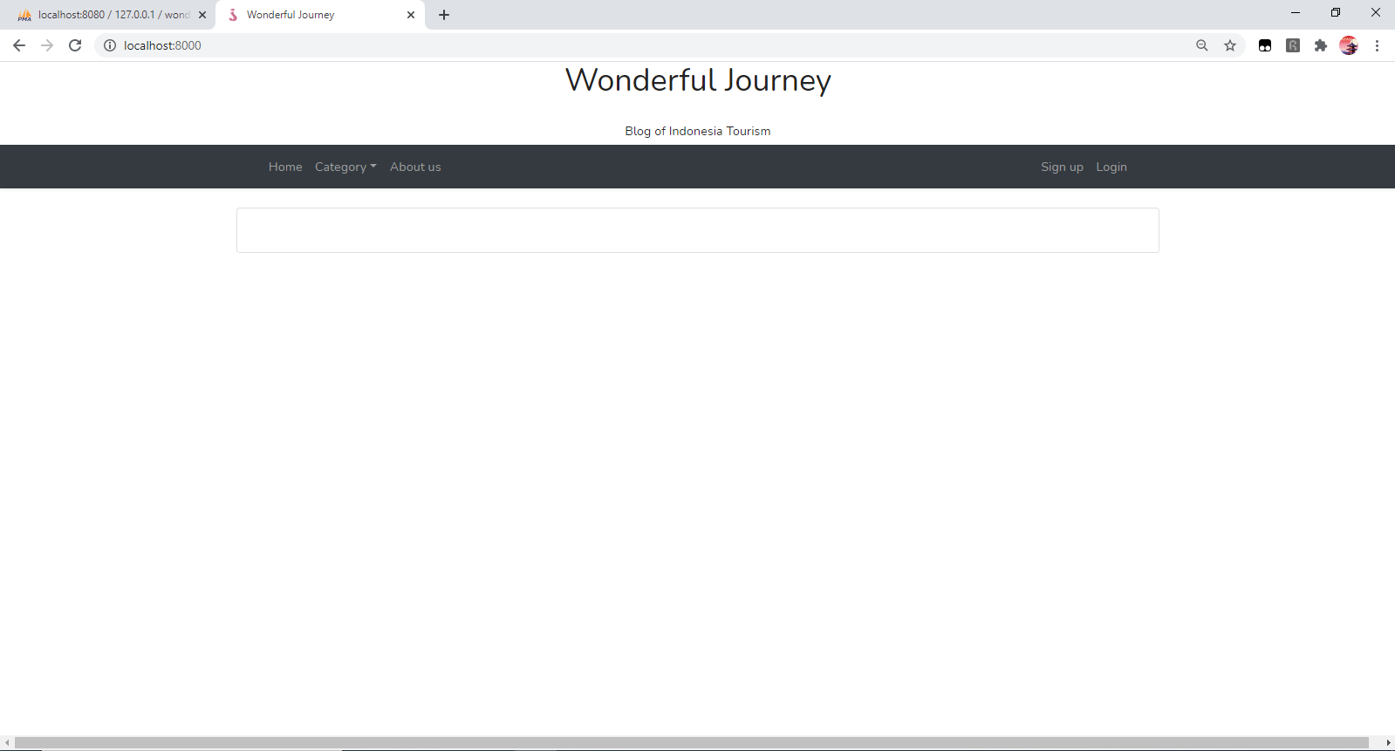

1. **Halaman About Us (Saya Isi Nama, NIM, dan Kelas Saya)**

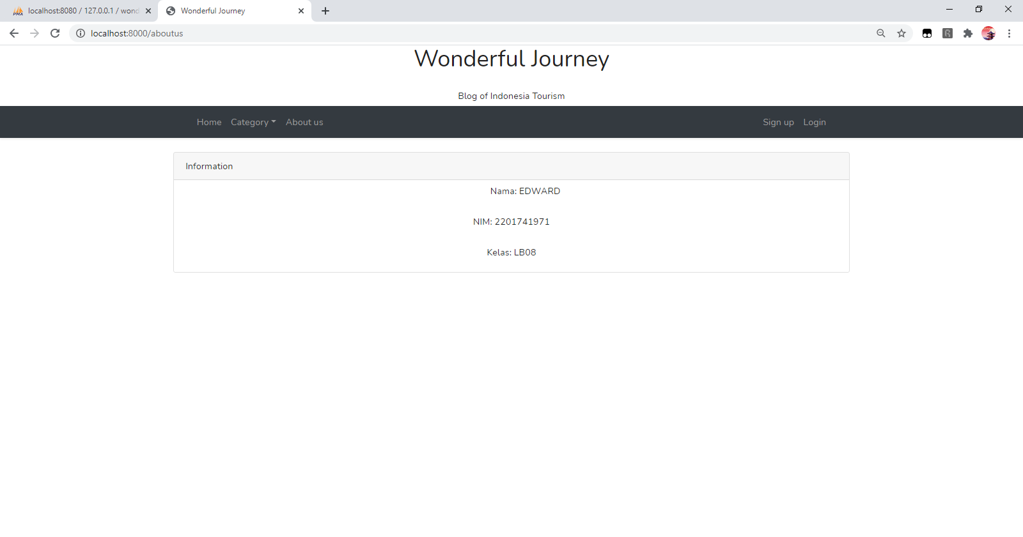

1. **Halaman Register**

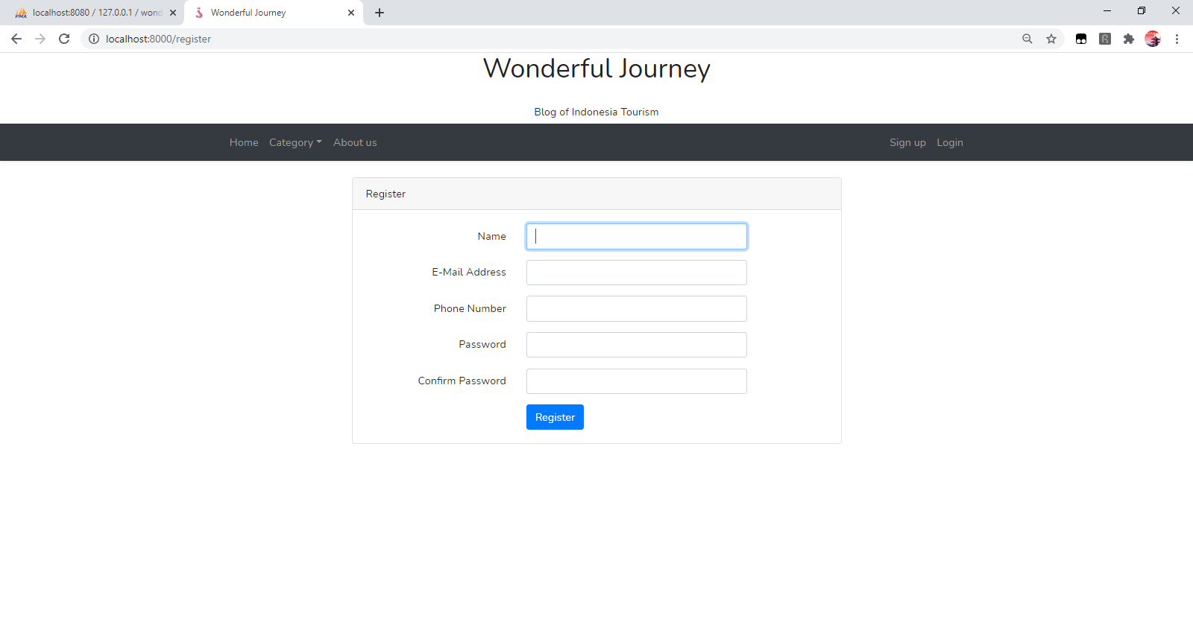

1. **Halaman Login**

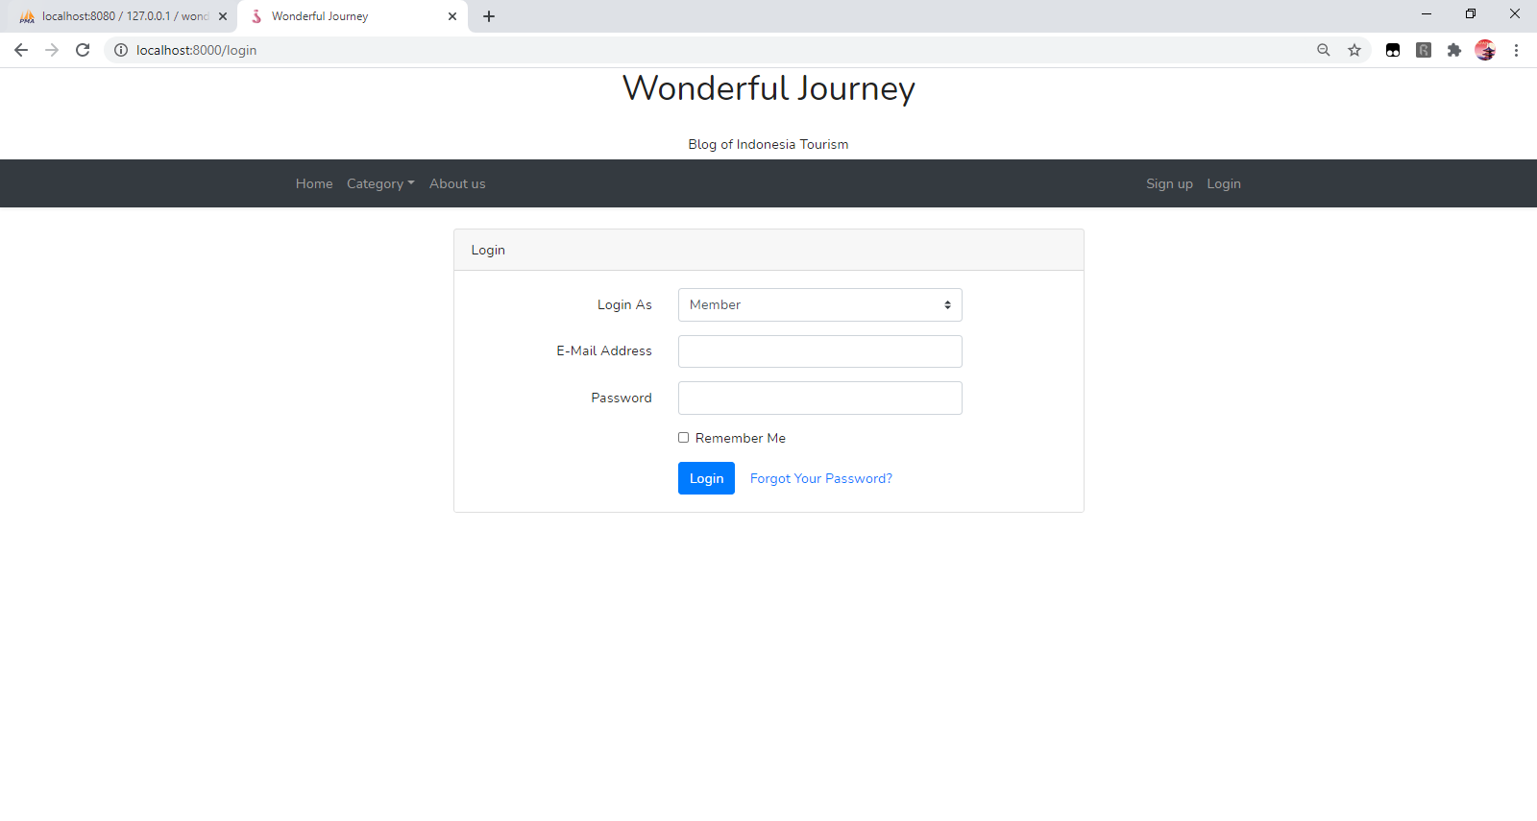

1. **Greeting Page Setelah Login**

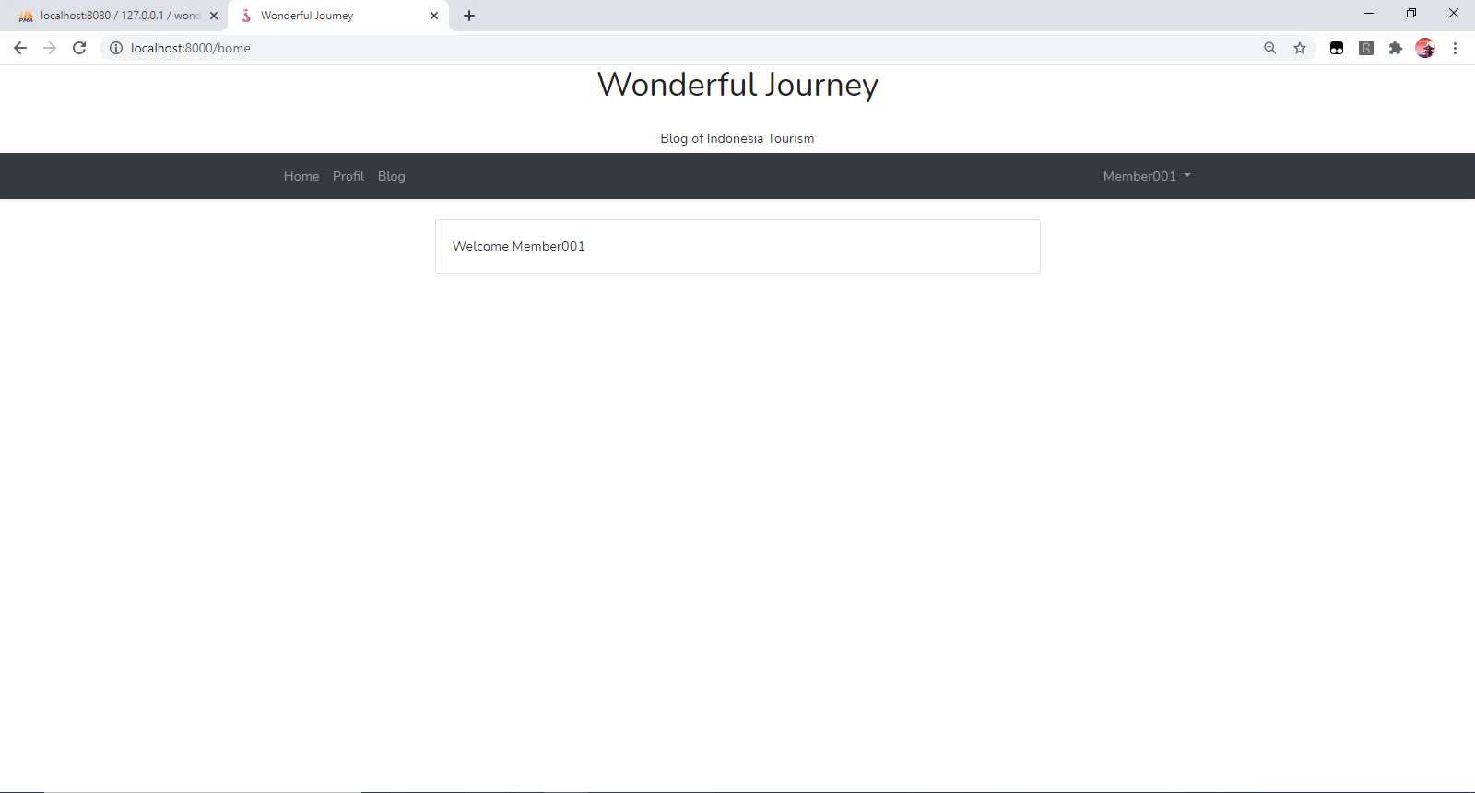

1. **Menu Update Profile (Member)**

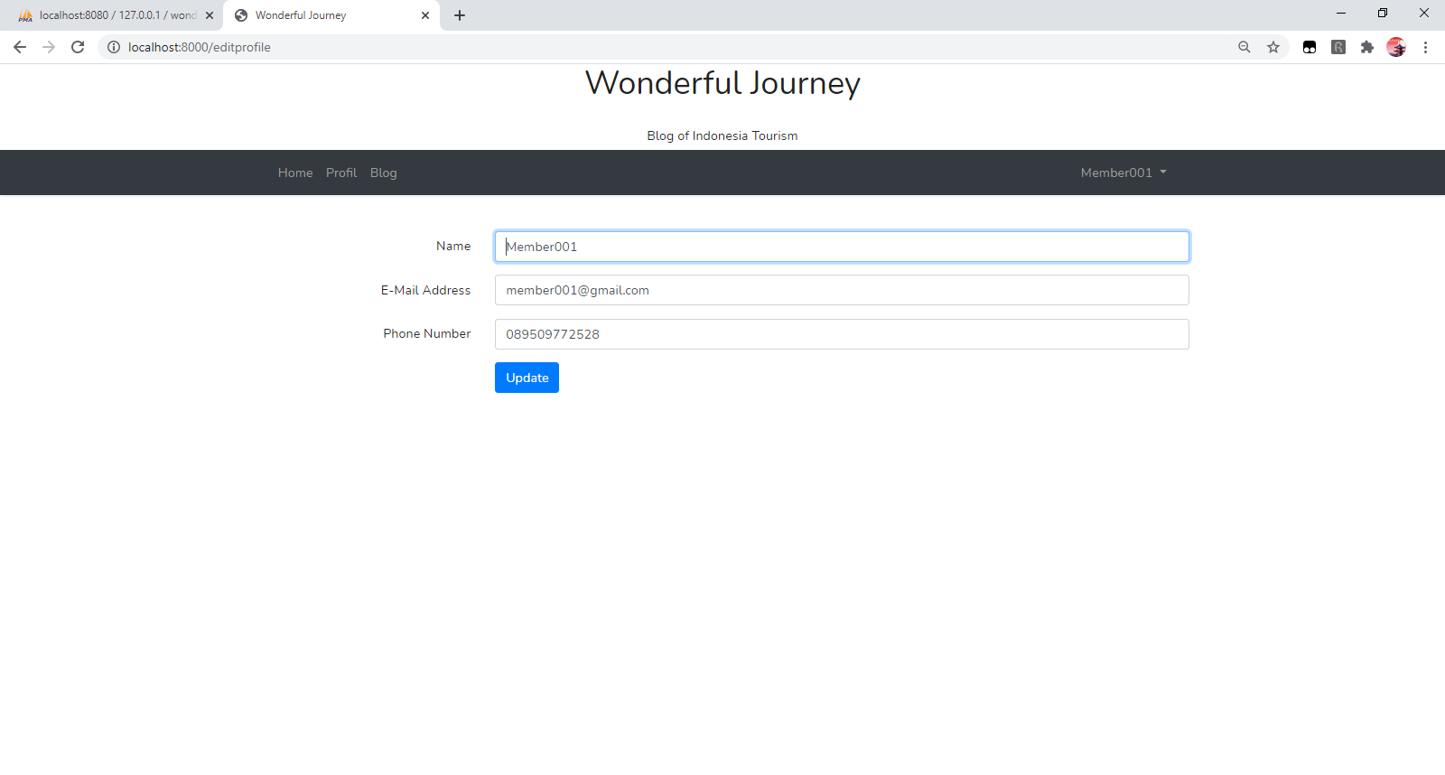

1. **Post New Blog (Can Delete and Edit Post)**

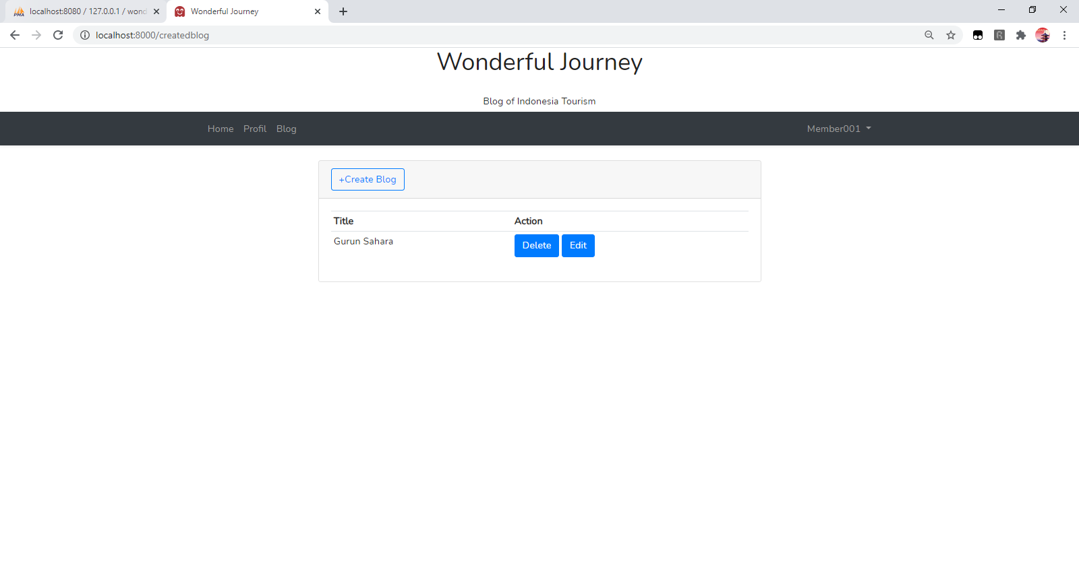

1. **Menu Home (Member)**

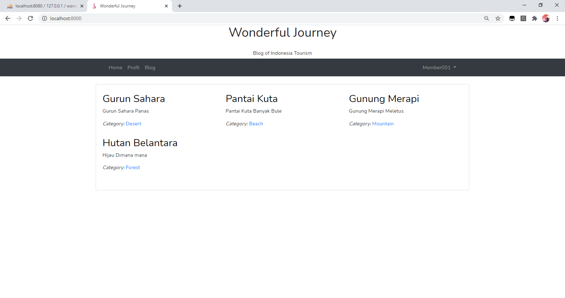

1. **Filter Post Based on Category**

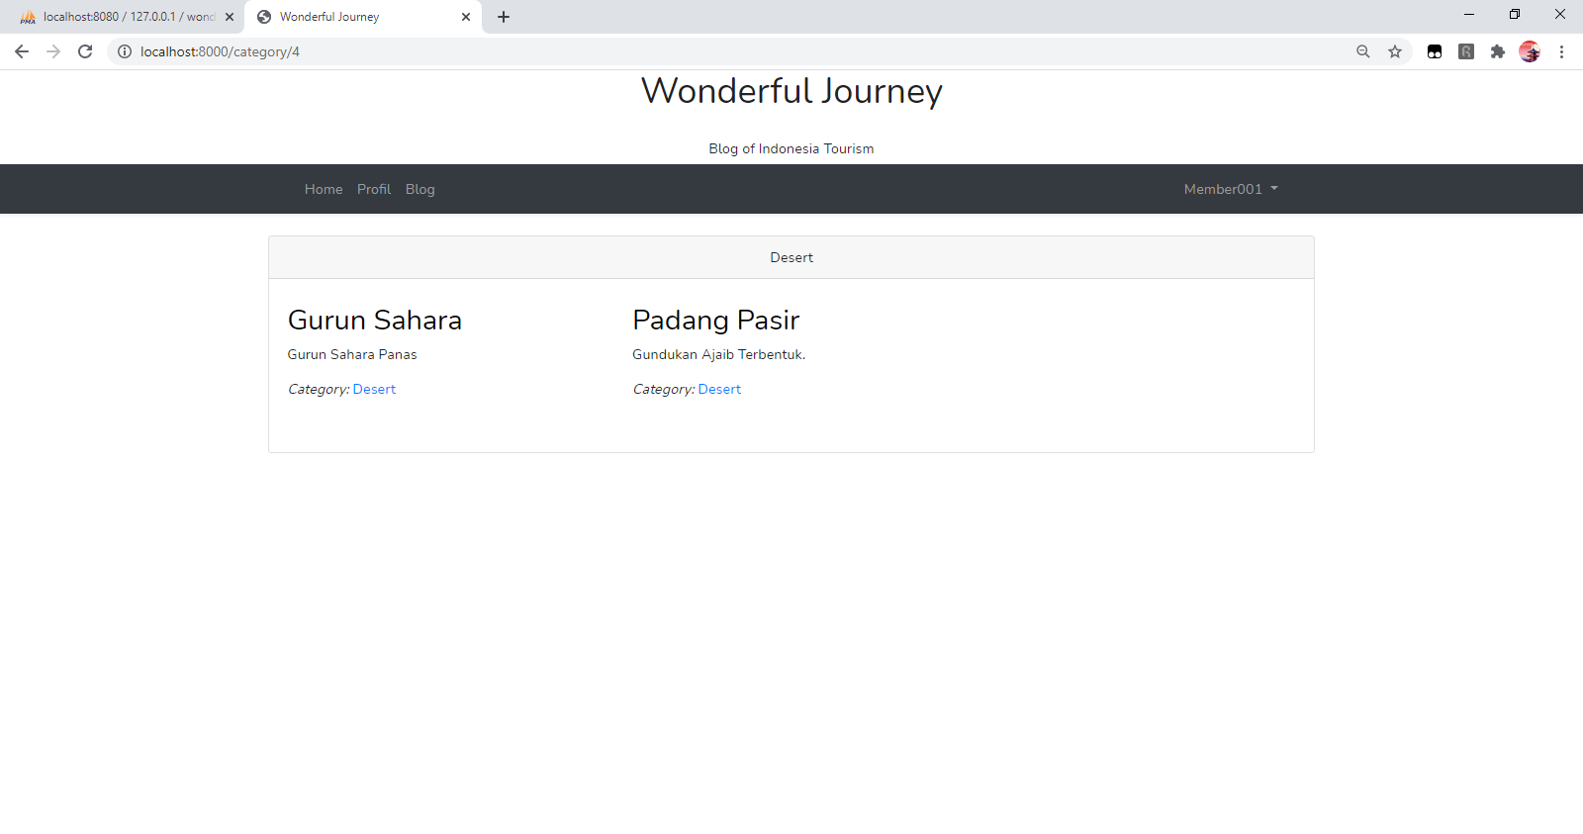

1. **Greeting Page (Admin Roles)**

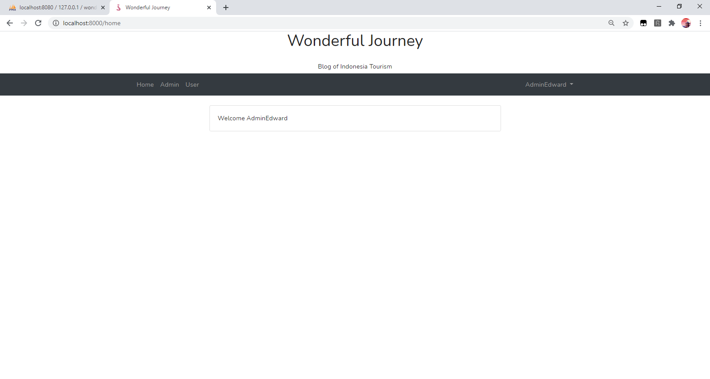

1. **See All User (Can Delete User)**

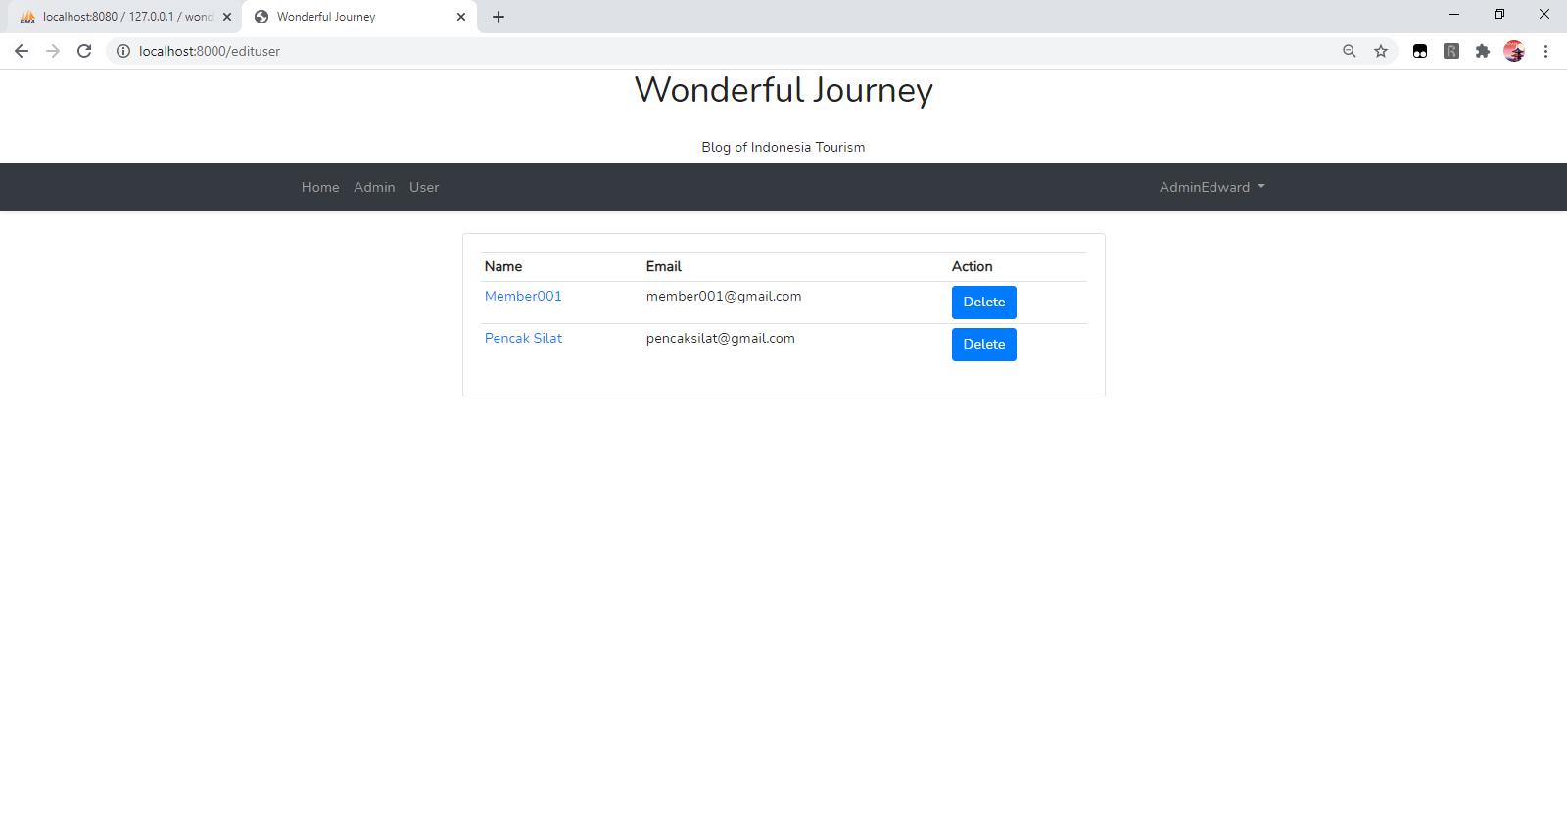

1. **See All Post with Name of the User who posted it (Can Delete the Blog Post)**

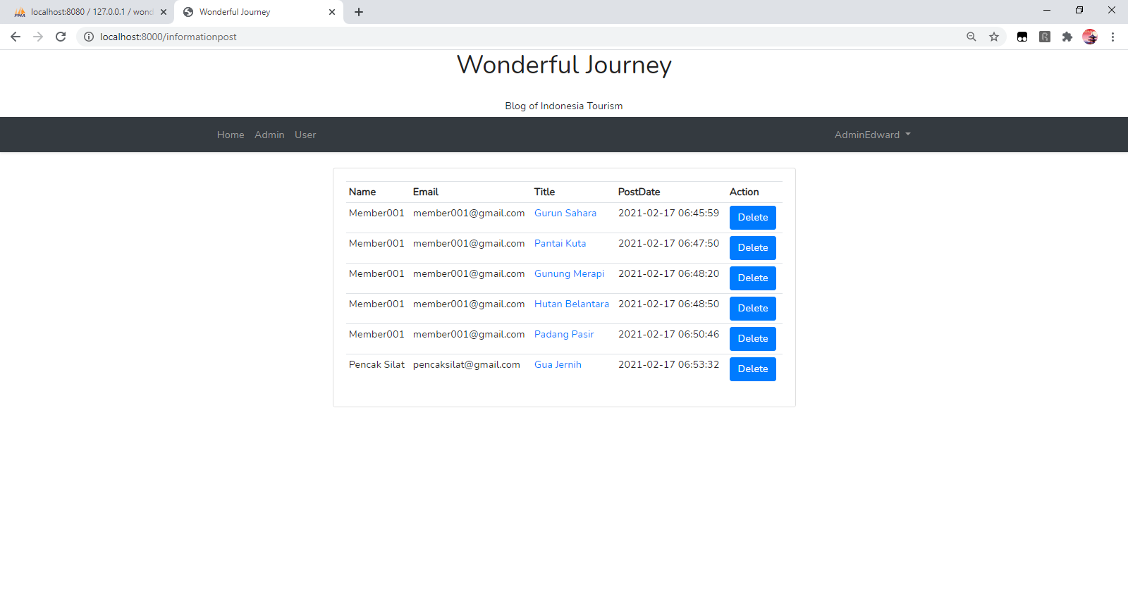

1. **See Detail Post of the Blog**

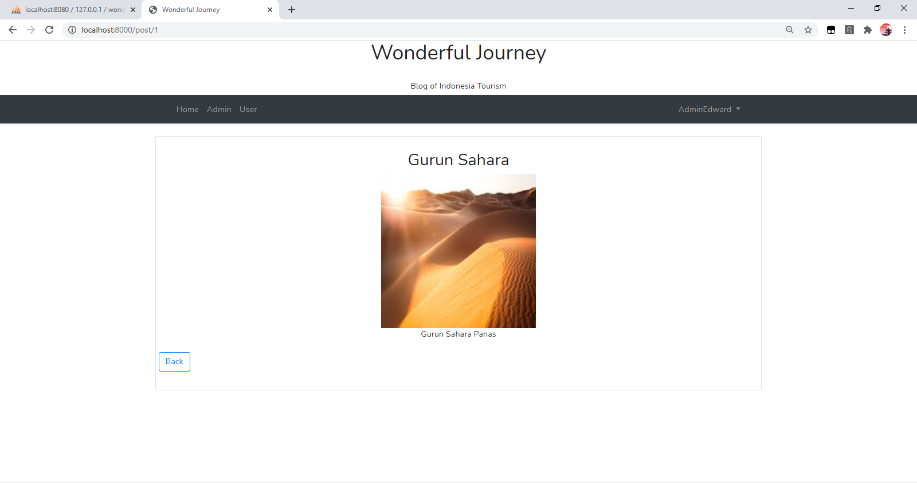

**LINK FILE JAWABAN UAS:**

<https://drive.google.com/drive/folders/1dQqbFG1_m7KzvoRqJMg9BIY3zx_WzTZq?usp=sharing>